MEMO
To: | Geri Glover, Ph.D., LPCC, NCC, RPT-S  Licensed School Counselor  Associate Professor & Chair Counseling Dept.
From: | Jessica Hurtado, MPA - Director of Admissions
Date: | 10/20/2019
Re: | CACREP Accreditation Visit Artifact
Slate Technolutions, which we commonly refer to as “Slate” is the Cadillac of customer relation systems (CRM) and is mostly widely used among colleges and universities globally to manage enrollment efforts. New Mexico Highlands University was the first institution in New Mexico to purchase and onboard phases of the Slate system, followed by New Mexico Institute of Mining and Technology and most recently New Mexico State University.
New Mexico Highlands University launched the application component of Slate on September 19, 2019, accepting applications in the new system. We are in our first phase of accepting applications and admitting students in Slate, focusing primarily on the Spring 2020 term in preparation for registration set to commence on November 11, 2019 – January 15, 2020.
Benefits for students: The system has the capability to accept admissions applications in one system – within one office – for all undergraduate and graduate domestic and international students, and allows for strategic enrollment planning as well as efficient processing and student notification. The system accepts payment by debit card, credit card, or electronic checks globally. Students have the ability to create their own unique login and access the student application portal, work on the application contents at their leisure, request professional letters of recommendation (professional dispositions) electronically, upload personal statements, report previous colleges attended, etc. Upon application submission, a student has the ability to log into their student application portal to check in real time what application items are pending such as receipt of a college transcript, and letters of recommendation, among other requested items. The system also generates automated emails to students at the time of applicant portal creation, if their application is incomplete, upon application submission, and once an admissions decision is released.
Benefits for NMHU faculty and staff:
The system is available for applicants to create an application account and work on the application 24 hours a day, 7 days a week. The system generates automated emails to students at the time of applicant portal creation, if their application is incomplete, upon application submission, and once an admissions decision is released. The system will allow faculty to search a student record and assist with any questions throughout the application process. The student record will provide demographic information that will be useful for faculty during advisement. The faculty will have access the students application such as personal statement, transcripts, professional dispositions, etc.
Application link is available on our Admissions Homepage: https://www.nmhu.edu/apply
The direct application link is: https://apply.nmhu.edu/apply/
Below is an image of the application homepage:
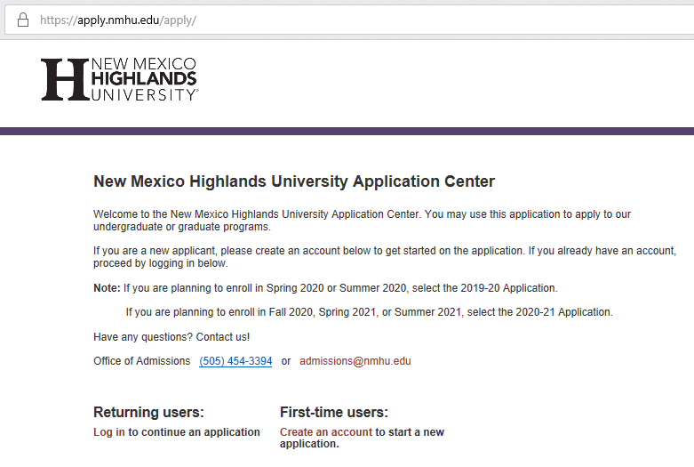
Below is a dashboard that showcases all applications in progress at NMHU, our team can filter this by School of Education graduate programs:
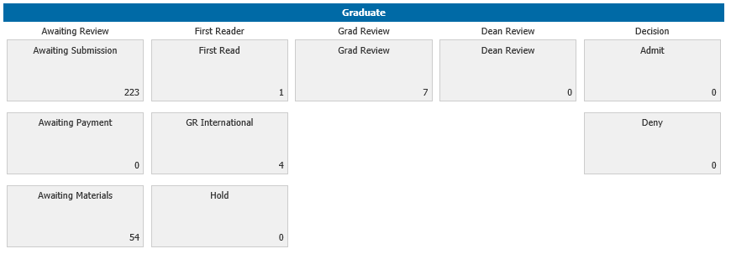
Below is an image of an automated sample admissions email that notifies the student of their admission, graduate program and campus location:
