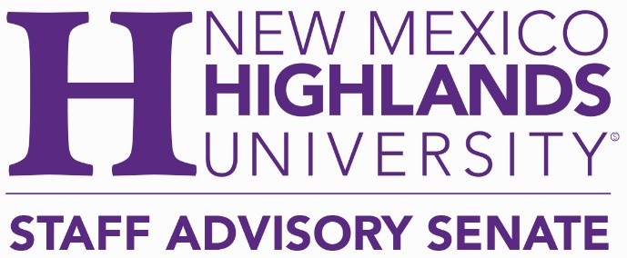
Regular Meeting October 7. 2021
Present: Veronica Black, Doris Gallegos, Inca Crespin, Anne Bradford, Robert Anaya, Marcy Silva, Carlos Nevarez, Buddy Rivera.
A quorum being established the meeting was opened by President Veronica Black at 2:35pm.
Approval of Agenda: Marcy made a motion to approve the agenda, Carlos seconded. Motion carried.
Senator’s Reports:
Marcy – Parliamentarian. Marcy is working with HR to correct the classification of the police department. When this is resolved she can move forward with a ballot for elections.
President’s report:
On the September 16 2021 meeting the results of the Quality Workplace Survey was tabled. Marcy Cathryn and Veronica compiled the results and identified those that we wanted to highlight and took them to President Minner. We walked him through the results we found and those we highlighted. The three areas that were prominent with the conversation with Dr. Minner. There were five areas that we can act upon now. The presentation was shared. Question 3 Have you received the training needed to complete your job effectively and question 10. Do you take classes by utilizing the NMHU tuition Reduction Program. The President wanted the SAS to focus on the tuition program.
Question 4. What kind of training would you like to receive? I list of training requested was shared.
Question 28 How interested would you be in the following Staff swag, More time off, and Flex schedule
72.8% voted very interested in Flex schedule. Dr. Minner mentioned there was no policy for employees to work remotely. SAS strongly recommends there be more consideration regarding flex schedules especially now during the pandemic. Departments could have a certain number in the office and others working from home so there is not so much interaction. The question is what does that look like for Highlands Who will create a flexible schedule and how do we support it and push it forward.
Question 30 Do you feel like you have the platform to voice your concerns, needs and ideas.?
Question31 AS an advocacy group for NMHU what can the Staff Advisory Senate do for you?

Veronica mentioned that they met with the President at the end of July or Early August and so it has been a while since this conversation and speaking with the Board regarding this. One thought was that there be a “dead” hour” where no meetings happen, just a solitary hour that can be used for catching up with emails, getting together with other departments, open office hours to voice concerns and ideas.
Inca asked “what’s next. Do we focus on the aforementioned goals or do we continue or start again.
Cathryn mentioned that NMHU instituted distance learning decades ago and so it is already in place even though there is no policy. We can write a policy for staff to be included as a remote work policy. The COVID caused an impromptu mandate. Cathryn mentioned that many people have expressed their concerns that if there is an inclement weather where they live or offices are shut down, or employees have children who are sick or any other family member COVID has proven that most offices can work from home, We now know that we can transition and work from home for safety reasons and so a policy can be produced to support those offices that are flexible. A policy should be inclusive and also support those offices that do not have that flexibility.
Marcy mentioned that she lived outside town and sometimes there is 2 feet of snow where she lives and nothing in town. She is then forced to take a day off and will take a mental health day. A policy should support anyone who has issues and can work from home. Inca expressed her concerns for those who do not have a choice like the police department and dispatchers. Cathryn proposed that perhaps we will need a tradeoff for those who have to be on campus to take a mental health day at no cost to them. Buddy brought up the point that if some cannot work from home there can be no equality therefore we should look at equity. It is a tough situation because you’re never going to be equal because there are so many variable.
We are unsure how we can move on with this. It was suggested that collaborating with the union might help. Doris pointed out that many were not union member and might have a different “take”’ this may not be something we, the SAS, can take on.
One of the things the President Minner wanted the SAS to think about is what a STAFF professional development Days would look like. This is something that we can work on. Veronica suggest that this was something we can put together. A proposal to create Staff development days Cathryn mentioned that printed materials are essential for people to be able to refer back to. Buddy said that timing is important as often staff cannot be available. Maybe a once a week training would work better. Marcy said that many trainings are poorly attended. The centers participation is also a concern. Supervisors will have to buy in to this and support their staff going to the trainings. Cathryn suggested that certificates of completion should be available and placed in their folder to show they are being a good employee. All agreed that Staff Professional Development Days was a good idea but the logistics might be difficult with understaffed departments and needing to find the time to attend. Veronica suggested that we write a proposal and put it on President Minner’s desk. Inca asked if the Employee Breakfast could be reinstated as this was the most attended event each year. She requested that Veronica mention this to Dr. Minner.
There was a discussion as to whether another survey should be conducted. Buddy suggested that we leave this for a year.
Cheryl asked when the survey was done. Answer: April 2020. Cheryl suggested another survey be conducted addressing the return to campus during COVID. Marcy said that ITS was working on a survey asking those questions. We could delay another survey until after the ITS survey results are public. It is important to have several years of data especially if the same issues arise year after year.
Veronica thanked Inca for her hard work on the Employee recognition in April. President Minner wants SAS to work on this Bringing back the employee breakfast could be a start. Perhaps we could send the centers a care package as they are not here on the Main campus.
Monthly employee of the Month is another initiative. She mentioned the Power of Service celebration of Customer Service Week where staff was asked to mention a Staff member who had been a great help.
Veronica met with University Relations and Sean Weaver is behind the initiative. Cathryn volunteered to produce a nomination form. She mentioned the custodian that went above and beyond to make sure that everything was clean and sanitized every day. We need a platform to recognize colleagues that help in this way.
Marcy has access to send Staff global emails and we will need to find a way to contact those who do not have access to computers.

The Board of Regents want action items for SAS by the next meeting. Veronica will share the survey results she will share our strategic plan. We do not have Board action items as we do not need their approval. .
Veronica sent an Email with information about EOC.
No one addressed the Senate.
The Staff Senate has had many special meetings this year so far.
Next scheduled meeting on Thursday
Veronica moved to adjourn Buddy seconded and the motion was carried. Meeting Adjourned at 4:o1pm

